Robotic PCB Design

Prepared By: Bushra Rehman
Project Demo using Tinkercad

Introduction
This project demonstrates a robotic PCB/circuit design created in Tinkercad using Arduino Uno and L293D motor driver. The circuit controls two DC motors, which can be used in a robotic car or movement-based robot.

Components Used

- Arduino Uno
- L293D Motor Driver
- 2 DC Motors
- 9V Battery
- Jumper Wires

Circuit Diagram

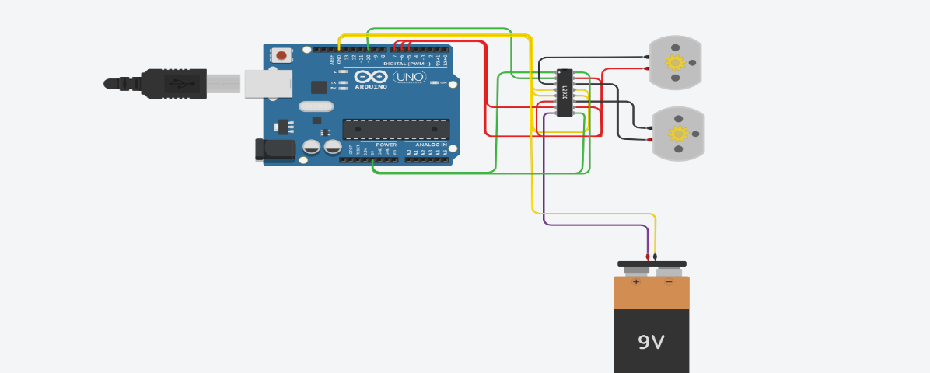

Connections
- Arduino 5V → L293D Pin 1, 9, 16
- Arduino GND → L293D Pin 4, 5, 12, 13
- Battery + → Pin 8
- Motors connected to output pins
- Digital pins used: D10, D9, D6, D5

Code
void setup()
{
pinMode(10, OUTPUT);
pinMode(9, OUTPUT);
pinMode(6, OUTPUT);
pinMode(5, OUTPUT);
}

void loop()
{
digitalWrite(10, HIGH);
digitalWrite(9, LOW);
digitalWrite(6, HIGH);
digitalWrite(5, LOW);
}

